Nexora member portal journeys
Document 25 of the Nexora learning guides
Source snapshot 13 October 2026 at 17:12 UTC
Understand the signed-in dashboard, profile, applications, memberships, organisations and inbox.

Recognise the screen and its scope
Open /portal, /portal/profile, /portal/memberships, /portal/applications, /portal/applications/[id], /portal/organisations, /portal/notifications. CRM routes use port 3017; member routes use 3018; public website routes can use 3019. Brackets name a route parameter, not text to paste into a browser. Choose a real record or site id from the application.
This guide covers Persistent member navigation; Dashboard totals and quick links; Structured profile and correspondence address; Application drafts submission evidence and receipts; Company grants and applications; Member notifications and read state.
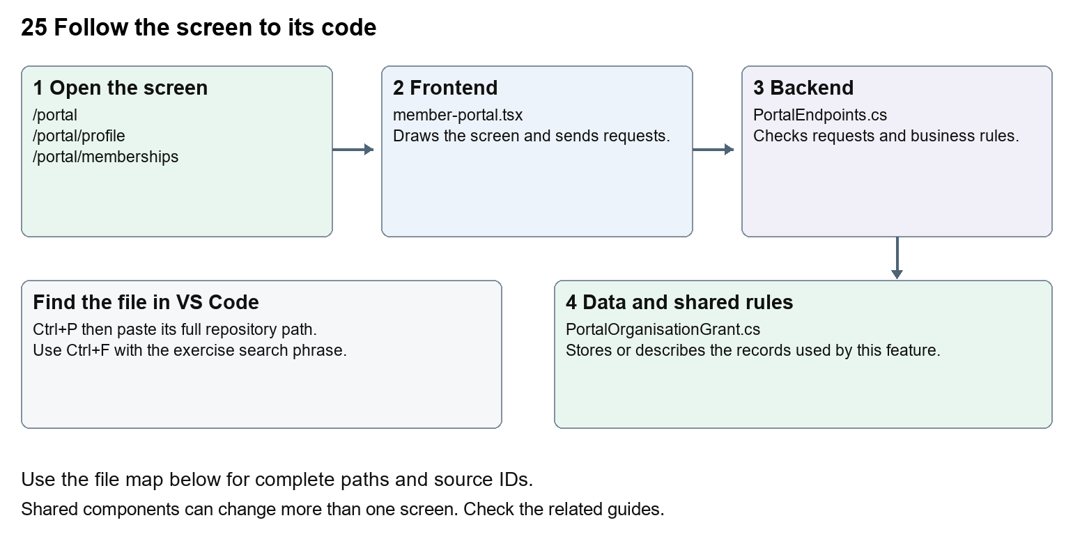
The diagram shows the file roles. The full paths below are what you paste into Ctrl+P.

Find the files in VS Code
Role | File and source ID | What it does
Screen | S0123 member-portal.tsx | Main UI or route for this topic
Server | S0399 PortalEndpoints.cs | Endpoints or server rules
Data | S0376 PortalOrganisationGrant.cs | Data shape or persistence structure

Screen S0123
apps/web/src/features/portal/member-portal.tsx
Server S0399
backend/src/Modules/Nexora.Modules.Identity/PortalEndpoints.cs
Data S0376
backend/src/Modules/Nexora.Modules.Identity/Domain/PortalOrganisationGrant.cs
The complete HTML manual opens these source IDs inside its Source library. The Word manual shows short labelled extracts so you can learn the flow before reading large files. Each individual Markdown guide includes its complete primary files after the walkthrough.

Follow the request and the records
1. The shared portal layout chooses the route section.
2. Profile and published presentation establish the signed-in view.
3. The selected component loads only its relevant records.
4. Personal or company requests go through /api/v1/portal with access checks.
5. Saving, submitting or marking read updates the stored record and refreshes the relevant view.

Read the code with an explanation
Portal routes often return null because the shared layout renders MemberPortal; editing the small route wrapper will not change the visible form. Organisation requests use an explicit accountId and grant check. A profile version prevents overwriting newer changes. sessionRevision and the expiry event keep delayed requests from restoring signed-out data.
Source reference S0123 apps/web/src/features/portal/member-portal.tsx
Selected opening lines with their original numbers. The complete file is in the HTML source library.
0001 "use client";
0002 import { useCallback, useEffect, useRef, useState } from "react";
0003 import { MemberDashboard } from "./member-dashboard";
0004 import { defaultPresentation, defaultPortalDesign, portalDesignStyle, type PortalPresentation } from "./presentation";
0005 import styles from "./portal.module.css";
0006 import { portal } from "./api";

The import lines lead to shared components and helpers. Start at the exported component or route function; follow the request helper to the server rather than assuming the whole feature lives in this file.
Source reference S0399 backend/src/Modules/Nexora.Modules.Identity/PortalEndpoints.cs
Extract from source line 37. A fragment from a long line is shown without the rest of that line.
0037 var portal = endpoints.MapGroup("/api/v1/portal").WithTags("Member portal");

On the server, look for MapGet to load records, MapPost to create or perform an action, MapPut or MapPatch to change data, and RequireAuthorization for permissions. Some shared methods register endpoints indirectly. Find SaveChangesAsync to see the database write. A request method alone does not tell you every side effect.
Source reference S0376 backend/src/Modules/Nexora.Modules.Identity/Domain/PortalOrganisationGrant.cs
Selected opening lines with their original numbers. The complete file is in the HTML source library.
0001 namespace Nexora.Modules.Identity.Domain;
0003 // Bound to one access grant, so revoking/replacing a login binding cannot revive delegation.
0004 public sealed class PortalOrganisationGrant
0005 {
0006 public Guid Id { get; set; } = Guid.NewGuid();
0007 public Guid TenantId { get; set; }

Follow model fields to their request names and database mapping. An id points to a particular record. A tenant id limits the organisation. A version or concurrency stamp protects newer edits. Some model files describe contracts rather than tables; check the owning DbContext before assuming storage.

Make or trace your first change
1. Press Ctrl+P and open apps/web/src/features/portal/member-portal.tsx.
2. Press Ctrl+F and search for Save profile. In this snapshot it appears at line 119.
3. Replace only the profile button text. Open /portal/profile and inspect it. Navigate to applications and Back, and check the shared shell remains consistent. Do not submit a real profile change for this exercise.
4. Replace only Save profile with Save my profile in that intended location. Keep quotes, tags, JSON keys and routes intact.
5. Save with Ctrl+S. Inspect Problems and the local screen. Review the diff and restore the original text when you finish practising.
Extract from source line 119. A fragment from a long line is shown without the rest of that line.
0119 className={button} disabled={busy}>Save profile</button><button type="button" className="und

These exercises have not been applied to the application. Their search phrases are verified against the captured source. Line numbers can move; the phrase and file path are your main navigation aids.

Check a change and diagnose problems
Confirm the original screen still loads, the changed words appear in the intended place, and another screen using the same component still behaves correctly. If an action fails, inspect the browser Network response, the relevant helper and server validation message. Use the common error table at the beginning of the manual. Reload on a version conflict instead of removing the version check.
A syntax error after a text edit usually means a quote, brace or closing tag changed. Compare your diff with the original. An unchanged browser result can mean the wrong port, a saved published configuration overriding a default, or a running API that has not reloaded.

Understand the current limits
Member visibility is limited to their Contact and explicit company grants. Application receipts confirm stored submission, not paid membership. Public website visitors are not automatically created as Contacts.

Continue learning
Related guides 09 Nexora member records and subscriptions, 10 Nexora membership applications and decisions, 24 Nexora member portal login and onboarding, 26 Nexora portal management, 29 Nexora documents evidence and file safety.

